Marshall County

Personal Information
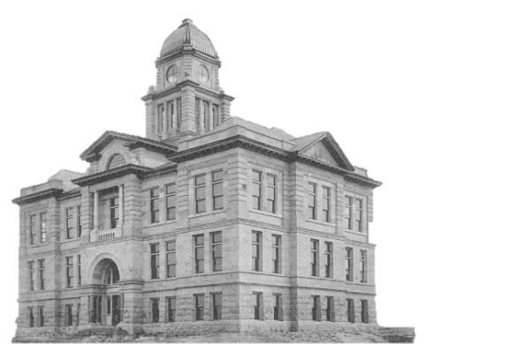
Full Name: _____________________________
Street Address: __________________________
City, State, Zip Code: _____________________
Phone Number: (___) _____________________
Email Address: __________________________
Have you ever applied to / worked for Marshall County before? [ ] Y or [ ] N
If yes, please explain (include date): ________________________

Do you have any friends, relatives, or acquaintances working for Marshall County? [ ] Y or [ ] N
If yes, state name & relationship: ________________________________

Are you over the age of 18? [ ] Y or [ ] N
If you are under the age of 18, do you have an employment/age certificate? [ ] Y or [ ] N
If hired, would you be able to present evidence of your U.S. citizenship or proof of your legal right to work in the United States? [ ] Y or [ ] N
Have you been convicted of or pleaded no contest to a felony within the last five years?
[ ] Y or [ ] N
If yes, please describe the crime - state the nature of the crime(s), when and where convicted, and the disposition (final settlement) of the case: ________________________________________________________________

Position and Availability
Position Applying For: ___________________________
Are you applying for
- Temporary work – such as summer or holiday work? [ ] Y or [ ] N
- Regular part-time work? [ ] Y or [ ] N
- Regular full-time work? [ ] Y or [ ] N
If applying for temporary work, indicate your desired length of employment below:
Start date: ___ / ___ / ___ End date: ____ / ____ / ____
Days/Hours Available
Monday ____
Tuesday ____
Wednesday ____
Thursday ____
Friday ____
Saturday ____
Sunday ____
Hours Available: from _______ to ______
Are you available to work overtime? [ ] Y or [ ] N
If hired, on what date can you start working? ___ / ___ / ___
Are you able to perform the essential functions of the job for which you are applying, either with / without reasonable accommodation? [ ] Y or [ ] N
If no, describe the functions that cannot be performed:
_____________________________________________________________

Education, Training and Experience
High School [ ] Y or [ ] N
GED [ ] Y or [ ] N
College / University [ ] Y or [ ] N If yes, complete column below.
College / University:
Number of years completed: ________
Did you graduate? [ ] Y or [ ] N
Degree / Diploma earned: __________________
Military:
Branch: ______________________________
Rank in Military:________________________
Total Years of Service: ________
Skills/Duties: __________________________________
Related Details:________________________________
Veteran Status: are you a veteran who received an honorable discharge and has:
- Provided more than 180 consecutive days of full time active duty in the armed forces of the United States or reserve components, including more than the National Guard? Or,
- Have a military service disability rating fixed by the United States Veterans Affairs?
[ ] Y or [ ] N
Skills and Qualifications: Licenses, Skills, Training, Awards
Use the following space to provide any additional information that you think would be helpful in our evaluation in your application. This can include specialized training, workshops, seminars, accreditation, special achievements or valuable skills:

Licenses Held (including drivers)
Type: ____________________________________
License Number: ____________________________________
Granted By (licensing board):____________________________________
Employment History
You should be prepared to detail each position for the past five years and account for any gaps in employment during that period.
Are you currently employed? [ ] Y or [ ] N
If you are currently employed, may we contact your current employer? [ ] Y or [ ] N
- Name of Employer:_____________________________________
Name of Supervisor:____________________________________
Telephone Number:_____________________________________
Business Type:________________________________________
Address:_____________________________________________
City, State, Zip:________________________________________
Length of Employment (Include Dates): _____________
Salary/Hourly Rate of Pay: ____________
Position & Duties: _______________________________________________________
Reason for Leaving: _____________________________________________________

- Name of Employer: _____________________________________
Name of Supervisor: ____________________________________
Telephone Number: _____________________________________
Business Type: ________________________________________
Address: _____________________________________________
City, State, Zip: ________________________________________
Length of Employment (Include Dates): _____________
Salary/Hourly Rate of Pay: ____________
Position & Duties: _______________________________________________________
Reason for Leaving: _____________________________________________________
May we contact this employer for references? [ ] Y or [ ] N

- Name of Employer:_____________________________________
Name of Supervisor:____________________________________
Telephone Number:_____________________________________
Business Type:________________________________________
Address:_____________________________________________
City, State, Zip:________________________________________
Length of Employment (Include Dates): _____________
Salary/Hourly Rate of Pay: ____________
Position & Duties: _______________________________________________________
Reason for Leaving: _____________________________________________________
May we contact this employer for references? [ ] Y or [ ] N
References: List below three persons who have knowledge of your work performance within the last four years. Please include professional references only.
- First and Last Name: _____________________________________
Telephone Number: ______________________________________
Email Address: __________________________________________
Address: _______________________________________________
City, state, zip: __________________________________________
Relationship: ____________________________________________
Number of Years Acquainted: ______________________________

- First and Last Name: _____________________________________
Telephone Number: ______________________________________
Email Address: __________________________________________
Address: _______________________________________________
City, state, zip: __________________________________________
Relationship: ____________________________________________
Number of Years Acquainted: ______________________________

- First and Last Name: _____________________________________
Telephone Number: ______________________________________
Email Address: __________________________________________
Address: _______________________________________________
City, state, zip: __________________________________________
Relationship: ____________________________________________
Number of Years Acquainted: ______________________________
Certification
I certify that the information contained in this application is true and complete. I understand that false information may be grounds for not hiring me or for immediate termination of employment if I am hired. I authorize the verification of any and all information listed above.
Signature: ______________________________ Date: ______________

