**Marshall County**

**Personal Information**

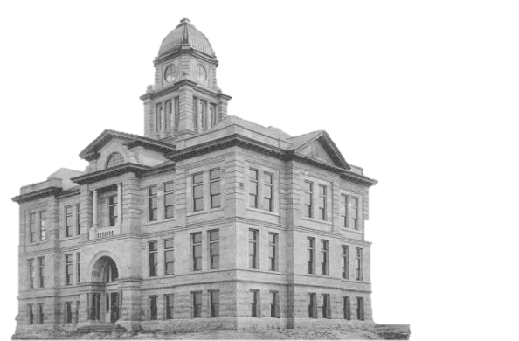

Full Name: _____________________________

Street Address: __________________________

City, State, Zip Code: _____________________

Phone Number: (___) _____________________

Email Address: __________________________

Have you ever applied to / worked for Marshall County before? [  ] Y or [  ] N  
If yes, please explain (include date): ________________________

Do you have any friends, relatives, or acquaintances working for Marshall County? [  ] Y or [  ] N  
If yes, state name & relationship: ________________________________

Are you over the age of 18?  [  ] Y or [  ] N

If you are under the age of 18, do you have an employment/age certificate?   [  ] Y or [  ] N

If hired, would you be able to present evidence of your U.S. citizenship or proof of your legal right to work in the United States? [  ] Y or [  ] N

Have you been convicted of or pleaded no contest to a felony within the last five years?

[  ] Y or [  ] N

If yes, please describe the crime - state the nature of the crime(s), when and where convicted, and the disposition (final settlement) of the case: ________________________________________________________________

**Position and Availability**

Position Applying For: ___________________________

**Are you applying for**

* Temporary work – such as summer or holiday work? [  ] Y or [  ] N
* Regular part-time work? [  ] Y or [  ] N
* Regular full-time work? [  ] Y or [  ] N

If applying for temporary work, indicate your desired length of employment below:

Start date: ___ / ___ / ___ End date: ____ / ____ / ____

**Days/Hours Available**

Monday ____  
Tuesday ____  
Wednesday ____  
Thursday ____  
Friday ____  
Saturday ____  
Sunday ____

Hours Available: from _______ to ______

Are you available to work overtime? [  ] Y or [  ] N

If hired, on what date can you start working? ___ / ___ / ___

Are you able to perform the essential functions of the job for which you are applying, either with / without reasonable accommodation? [  ] Y or [  ] N

If no, describe the functions that cannot be performed:  
_____________________________________________________________

**Education, Training and Experience**

**High School** [  ] Y or [  ] N

**GED** [  ] Y or [  ] N  
**College / University** [  ] Y or [  ] N If yes, complete column below.

**College / University:**

Number of years completed: ________  
Did you graduate? [  ] Y or [  ] N  
Degree / Diploma earned: __________________

**Military:**  
Branch: ______________________________  
Rank in Military:________________________  
Total Years of Service: ________  
Skills/Duties: __________________________________  
Related Details:________________________________

**Veteran Status**: are you a veteran who received an honorable discharge and has:

1. Provided more than 180 consecutive days of full time active duty in the armed forces of the United States or reserve components, including more than the National Guard? Or,
2. Have a military service disability rating fixed by the United States Veterans Affairs?

[  ] Y or [  ] N

**Skills and Qualifications: Licenses, Skills, Training, Awards**

Use the following space to provide any additional information that you think would be helpful in our evaluation in your application. This can include specialized training, workshops, seminars, accreditation, special achievements or valuable skills:

**Licenses Held (including drivers)**

Type: ____________________________________

License Number: ____________________________________

Granted By (licensing board):____________________________________

**Employment History**

You should be prepared to detail each position for the past five years and account for any gaps in employment during that period.

Are you currently employed?  [  ] Y or [   ] N

If you are currently employed, may we contact your current employer? [  ] Y or [  ] N

1. Name of Employer:_____________________________________  
   Name of Supervisor:____________________________________  
   Telephone Number:_____________________________________  
   Business Type:________________________________________  
   Address:_____________________________________________  
   City, State, Zip:________________________________________

Length of Employment (Include Dates): _____________

Salary/Hourly Rate of Pay: ____________  
Position & Duties: _______________________________________________________  
Reason for Leaving: _____________________________________________________

1. Name of Employer: _____________________________________  
   Name of Supervisor: ____________________________________

Telephone Number: _____________________________________  
Business Type: ________________________________________  
Address: _____________________________________________  
City, State, Zip: ________________________________________

Length of Employment (Include Dates): _____________

Salary/Hourly Rate of Pay: ____________  
Position & Duties: _______________________________________________________  
Reason for Leaving: _____________________________________________________

May we contact this employer for references? [  ] Y or [  ] N

1. Name of Employer:_____________________________________  
   Name of Supervisor:____________________________________  
   Telephone Number:_____________________________________  
   Business Type:________________________________________  
   Address:_____________________________________________  
   City, State, Zip:________________________________________

Length of Employment (Include Dates): _____________

Salary/Hourly Rate of Pay: ____________  
Position & Duties: _______________________________________________________  
Reason for Leaving: _____________________________________________________

May we contact this employer for references? [  ] Y or [  ] N

**References**: List below three persons who have knowledge of your work performance within the last four years. Please include professional references only.

1. First and Last Name: _____________________________________  
   Telephone Number: ______________________________________  
   Email Address: __________________________________________  
   Address: _______________________________________________  
   City, state, zip: __________________________________________  
   Relationship: ____________________________________________  
   Number of Years Acquainted: ______________________________
2. First and Last Name: _____________________________________  
   Telephone Number: ______________________________________  
   Email Address: __________________________________________  
   Address: _______________________________________________  
   City, state, zip: __________________________________________  
   Relationship: ____________________________________________  
   Number of Years Acquainted: ______________________________
3. First and Last Name: _____________________________________  
   Telephone Number: ______________________________________  
   Email Address: __________________________________________  
   Address: _______________________________________________  
   City, state, zip: __________________________________________  
   Relationship: ____________________________________________  
   Number of Years Acquainted: ______________________________

**Certification**

I certify that the information contained in this application is true and complete. I understand that false information may be grounds for not hiring me or for immediate termination of employment if I am hired. I authorize the verification of any and all information listed above.

Signature: ______________________________ Date: ______________